Forensic examination of Azhar et al.’s (2026) data and results

Summary

- The authors stated that the errors in the results (primarily Table 3 and corresponding numbers in text) are due to SD/SE confusions
- The authors supplied an excel file to confirm the above, which they stated represents the underlying data.
- However, the data contained in this dataset contains serious inconsistencies. The sum scores used to calculate the outcome effect sizes should be identical between the raw data sheet and the statistical analysis sheet in the excel file, but the values differ substantially at both the group and individual level. Eg, anxiety outcome measure: raw sheet’s Cohen’s d = 0.5, stats sheet Cohen’s d = 3.4.
- Neither sheet’s data reproduces the results reported in Table 3 precisely, although results are generally closer to the stats sheet.
- Further inconsistencies about the design and data are raised. The article states both that a) there was zero missingness b) that imputation was used to handle missingness. The shared excel file does not show any missingness, but it is unclear if this was before or after any imputation that may have occurred.
- Deeper questions about the source of the two different datasets are raised. Which represents the real data, if either does? How did the other(s) arise?
- The articles results need very substantial revision at minimum. Larger questions about the research process than generated the data may raise more fundamental concerns.

Details

In their email to the editor, the authors stated:

“Regarding the statistical concerns, we have identified that the inconsistencies across tables arose during manuscript revision and table preparation. Specifically, standard errors of the mean (SEM) were inadvertently copied and presented in place of standard deviations (SD) in some tables during the copy-and-paste process used to assemble the final manuscript tables. This was a reporting and presentation error rather than an issue with the participant-level data or the study conduct. As a consequence, effect size estimates derived from these values appeared inflated and inconsistent across tables. We apologise for any confusion caused by this error.
Importantly, the anonymised, coded participant-level dataset remains intact, and no participant values were altered. The underlying analyses were conducted on the correct data; however, the descriptive statistics and derived estimates require correction. We are therefore recalculating all means using the correct cell references, reporting SD rather than SEM, and rerunning the regression analyses accordingly. We are prepared to submit corrected tables and updated analyses for the journal’s review.”

This set of analyses inspected the supplied data and sought to assess the accuracy of these statements.

Note that the supplied data file contains three sheets:
- Sheet named “scales C,I”: what appear to be the raw data and the calculation of outcome variable sum scores out of item scores. Hereafter “raw”.
- Sheet named “data for statstics” [sic]: what appear to be the participant level sum scores, copied from raw, and the calcualtion of the results. Hereafter referred to as “stats”.
- A third sheet containing data from the recruitment and screening, which we did not examine.

Reproduction of Table 3 from the supplied data

Table 3 as reported in the article

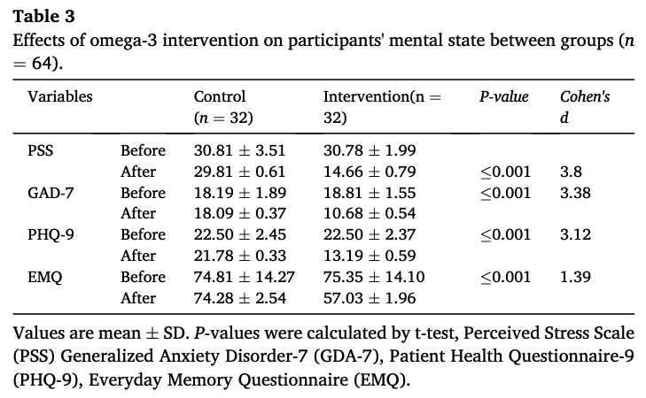

M/SD

We reproduced Table 3 from the supplied data
- Calculating the error terms as either SEs or SDs
- Calculating the results from either the raw or stats sheets

± are SDs:
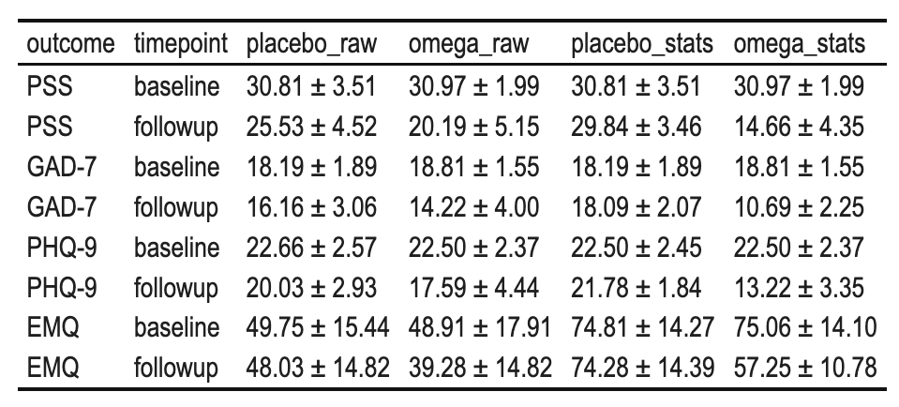

± are SEs:

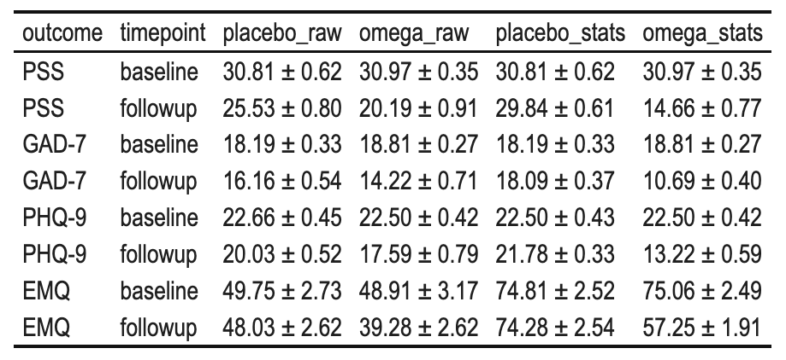

Conclusions:

- The ± likely represent a mix of SEs and SDs.
  - This supports the authors’ statements that there was, at minimum, SE/SD confusion.
- However, neither the raw nor stats sheets can reproduce the means and ± terms reported in the article’s table 3.
- There is greater match between the means in Table 3 and those calculated from the stats sheet than the raw sheet, and the two do not match.
  - The previous two points suggest the atuhors’ statements are incomplete: there are also unacknowledged reproducbility issues.

Cohen’s d

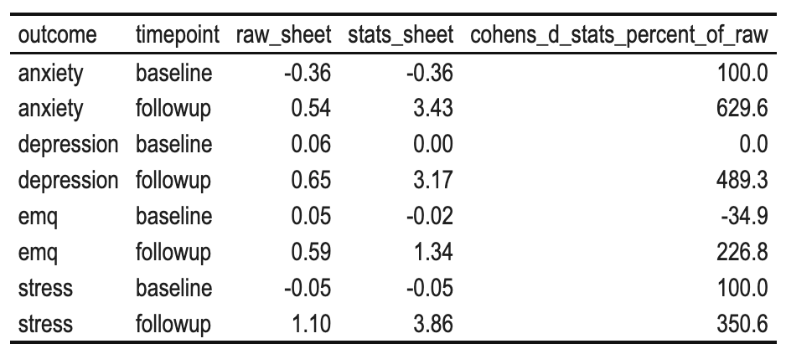

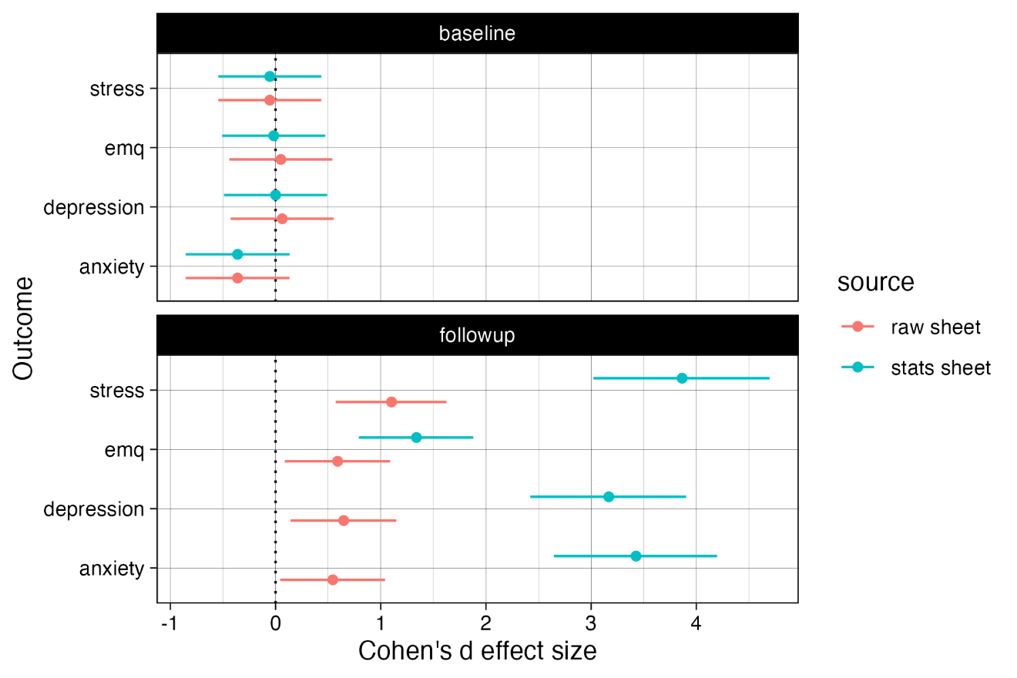

- The Cohen’s d values do not match those reported in the article’s Table 3.
- The values recalculated from the stats sheet are much closer than those from the raw sheet.
- However, the stats sheet’s sum scores do not match the raw data, as shown above. Cohen’s ds are inflated by up to +500% in the stats sheet compared to the raw sheet.

Comparing participant level data between the raw and stats sheets

We compared each participant’s sum scores between the raw sheet (which calculates the sum scores) and the stats sheet (which should, presumably, contain the same data copied and pasted).

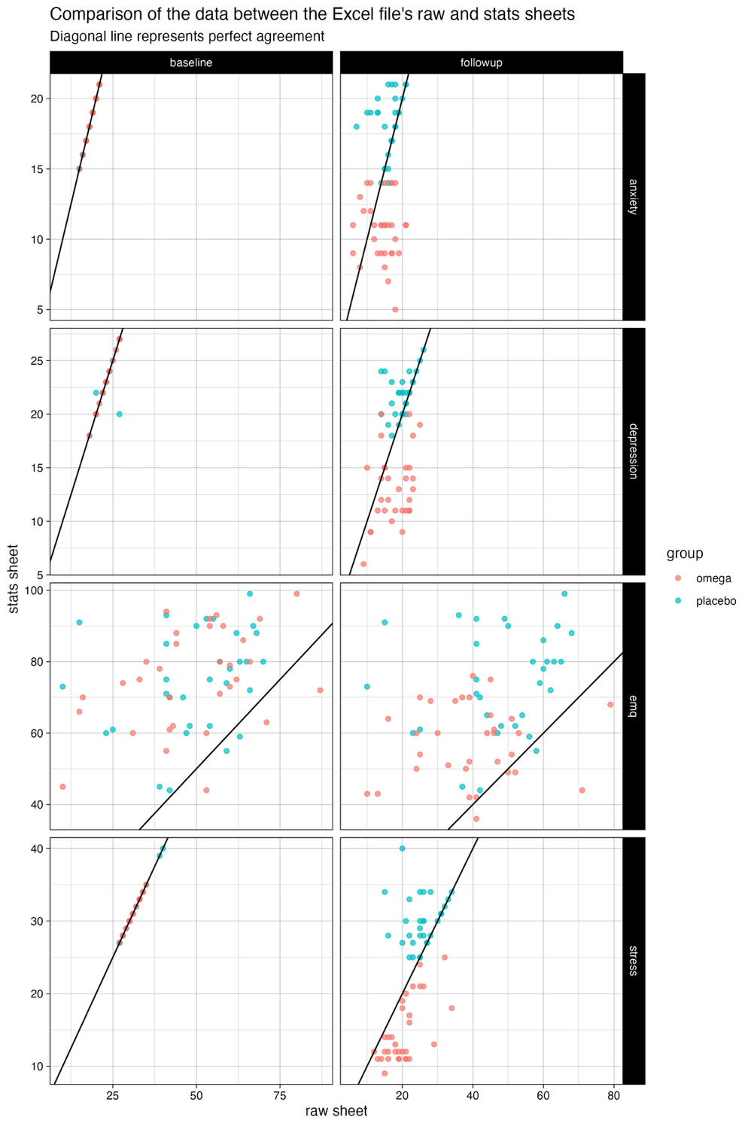

Substantial differences exist between the data on the two sheets, especially at post intervention.
At the group level, the differences between the groups are more extreme in the stats sheet, with both intervention and control groups further away from their data in the raw sheet.
At the individual level, differences between the two sheets are irregular/heterogeneous, with no clear pattern. The attached files (see analysis.html) document the participant level differences between the two sheets, on each column.

Substantial questions are raised about how the differences in the sum score data between the two sheets arose.

Given that the raw sheet is presented as where the sum scores are calculated, they can reasonably be assumed to represent the data source closer to the original data. However, this does not mean that we can assume that the raw data sheet represents the original, raw, unperturbed data. The article states
- "Missing questionnaire items (<5 %) were imputed using series mean substitution; participants with >20 % missing data were excluded."
- " Sixty-four eligible participants consented and were randomized; all completed both baseline and post-intervention assessments and were included in the perprotocol analysis."
These statements are incompatible with one another: either there was missingness or not.

The article also states that all analyses were conducted in SPSS v24, but a) analyses seem to have been conducted in the excel stats sheet, and b) this excel file cannot be loaded into SPSS due to the use of mulitple header and summary rows. Can the authors clarify the details of their study, resolve and explain these inconsistencies, and state whether any other reported details of the study are inaccruate?

Reproducible code and data can be found attached. More analyses and comparisons of the sheets is included in the analysis.html file.

